

GROWWPARK TECHNOLOGIES

PRIVATE LIMITED

AN INTERNSHIP REPORT

Submitted to the partial fulfilment of the requirement for the award of the degree of

BACHELOR OF ENGINEERING
in

COMPUTER SCIENCE AND ENGINEERING

Internship Report submitted by:

AMIRTHA ANITHA R(2403737710422061)

Company Guide:

Mr.AKILESH A
Growwpark Technologies Private Limited

Faculty Guide:

Mr. S. VADIVEL

Internship Period:
21.12.2025 – 22.01.2026

K. S. RANGASAMY COLLEGE OF TECHNOLOGY
(An Autonomous Institution, affiliated to Anna University Chennai and Approved by AICTE, New Delhi)

TIRUCHENGODE – 637 215

JANUARY 2026

K. S. RANGASAMY COLLEGE OF TECHNOLOGY TIRUCHENGODE - 637 215
BONAFIDE CERTIFICATE

Certified that this internship report titled Growwpark Technologies Pvt Ltd is the bonafide work of AMIRTHA ANITHA R (2403737710422061) who carried out the Internship under my supervision. Certified further, that to the best of my knowledge the work reported herein does not form part of any other Internship report or dissertation on the basis of which a degree or award was conferred on an earlier occasion on this or any other candidate.

SIGNATURE

Mr. S. VADIVEL M.E.,

INTERNSHIP COORDINATOR
Assistant Professor
Department of Computer Science and Engineering
K.S. Rangasamy College of Technology Tiruchengode - 637 215
SIGNATURE

Dr. B.G.GEETHA M.E., Ph.D.,

HEAD OF THE DEPARTMENT
Professor
Department of Computer Science and Engineering
K.S. Rangasamy College of Technology Tiruchengode - 637 215

Submitted for the internship evaluation held on ………………..........

CERTIFICATE

- Internship Acceptance Letter

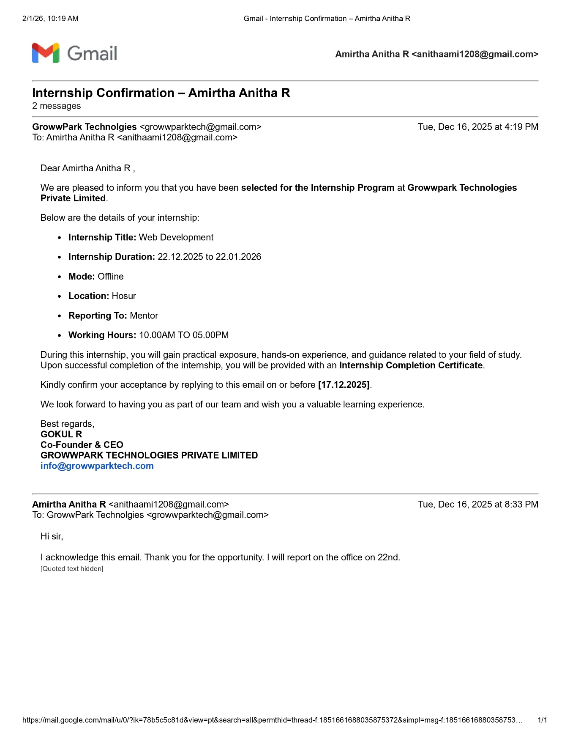

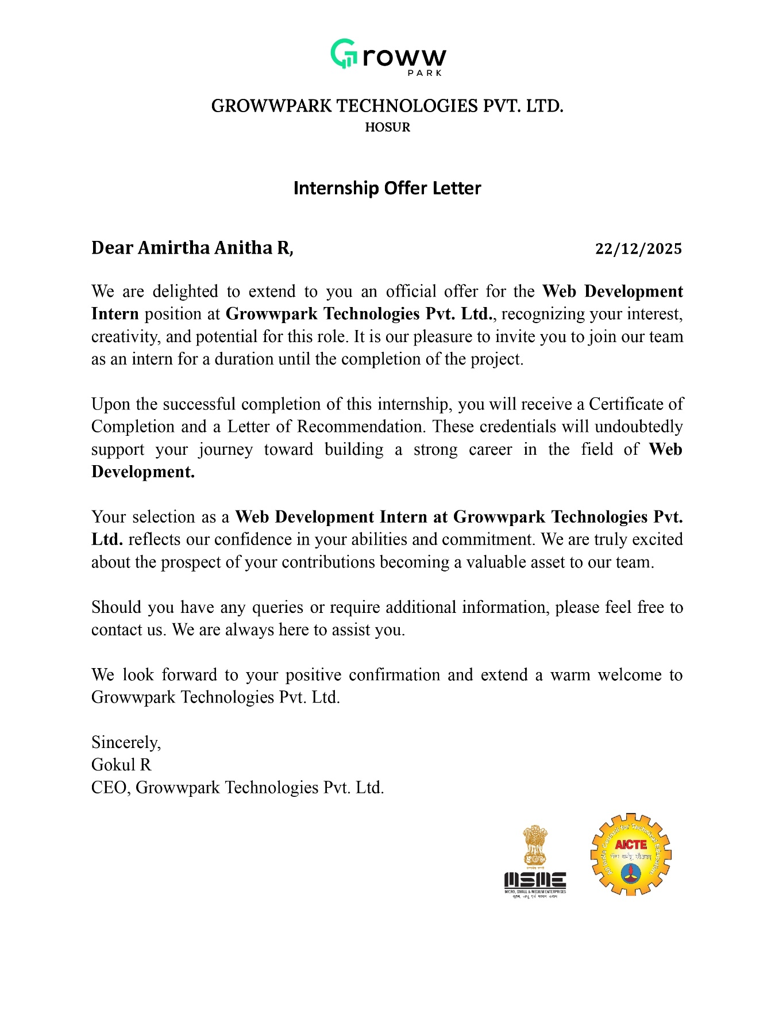

- Internship Completion Certificate

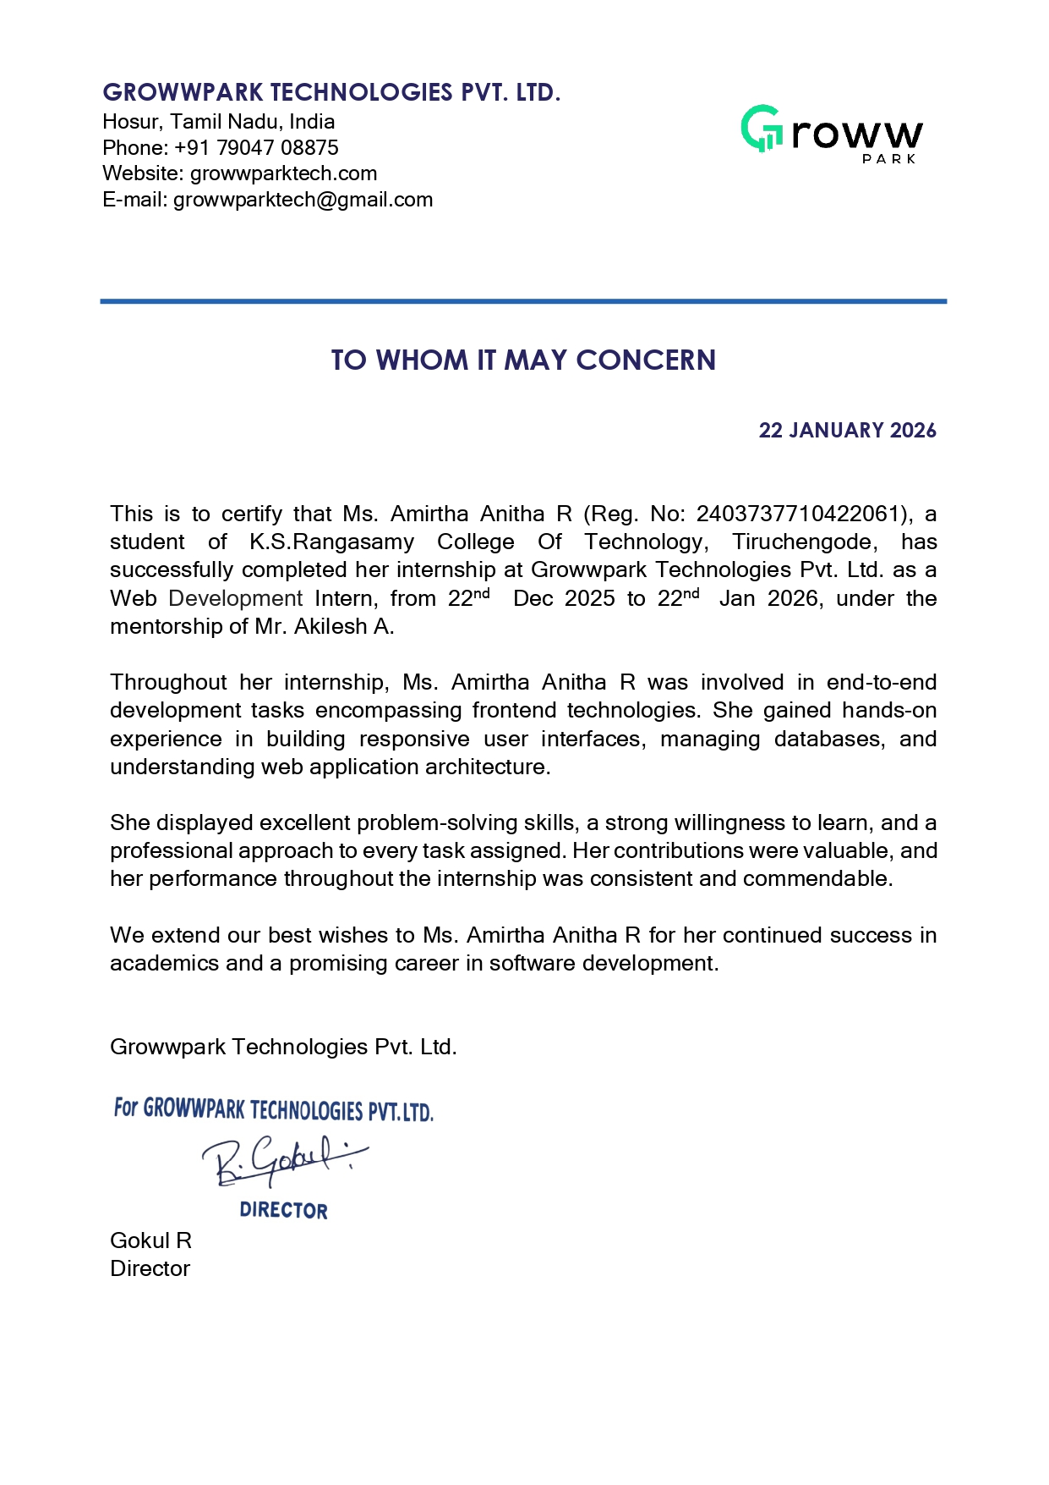

DECLARATION

I declare that the Internship report on Growwpark Technologies Pvt Ltd is the result of original work done by me and best of my knowledge, similar work has not been submitted to “ANNA UNIVERSITY CHENNAI” for the requirement of Degree of Bachelor of Engineering in Computer Science and Engineering. This Internship report is submitted on the partial fulfilment of the requirement of the award of Degree of B.E.

Signature

AMIRTHA ANITHA R

Place: Tiruchengode Date:

ACKNOWLEDGEMENT

I wish to express my sincere gratitude to our honorable Chairman
Mr. R. SRINIVASAN B.B.M., MISTE., for providing immense facilities at our institution.

I am very proud to render my thanks to our Principal
Dr. R. GOPALAKRISHNAN M.E., Ph.D., for extending the resources and the consistent encouragement given by him for the progress and completion of my project.
I proudly render my immense gratitude to the Head of the Department Dr. B.G.GEETHA M.E., Ph.D., for her guidance and support in shaping the direction of this project. Your insightful feedback and expertise have been instrumental in refining our approach and methodology.
I am highly indebted to provide my heart full thanks to our internship coordinator Mr. S. VADIVEL M.E., Assistant Professor for his valuable ideas, encouragement and supportive guidance throughout the project. Your constructive criticism and attention to detail have greatly contributed to the quality of this report.
I would also like to provide my heartfelt thanks to my mentor,
Dr. A.GNANABASKARAN, M.E., Ph.D., Associate Professor, for his valuable ideas, encouragement, and supportive guidance.
I would also like to extend my appreciation to all those who have directly or indirectly contributed to this project. Your contributions have been invaluable in making this endeavour a success.

TABLE OF CONTENTS

CHAPTER | TITLE | PAGE NO
1 | Introduction | 9
2 | Company Overview | 10
3 | Internship Objectives | 11
4 | Projects Overview | 12
5 | Learning Outcomes | 19
6 | Challenges Faced | 21
7 | Conclusion | 23
8 | References | 24

CHAPTER 1

Introduction

I secured my internship at Growwpark Technologies Pvt. Ltd., Hosur, Tamil Nadu, after being selected for their Web Development Internship program. The internship was offered after an evaluation of my interest and basic knowledge in web development concepts. Upon successful selection, I was assigned the role of Web Development Intern under professional guidance.

This internship provided me with a structured opportunity to gain hands-on experience in frontend web development. At the beginning of the internship, my primary objective was to strengthen my practical understanding of HTML, CSS, and JavaScript, which I had previously studied academically but had limited exposure to in a real-time professional environment. I was particularly eager to learn how these technologies are used together to build functional and responsive websites.

Going into the internship, my expectations were high. I aimed to gain a clear understanding of how professional web applications are designed and developed, and how frontend technologies contribute to creating user-friendly interfaces. I also wanted to understand how developers approach tasks, follow best practices, and maintain consistency in web design.

Throughout the internship period from 22nd December 2025 to 22nd January 2026, I was actively involved in various frontend development tasks. These tasks included creating structured web pages using HTML, designing layouts and responsive interfaces using CSS, implementing interactivity using JavaScript, and deploying websites using the Netlify hosting platform. I gained hands-on experience in hosting web applications, managing builds, and making projects live on a server.

Through this internship, I also focused on developing essential professional and soft skills. I improved my problem-solving abilities, attention to detail, and time management while completing assigned tasks. Working under the mentorship of Mr. Akilesh A, helped me understand the importance of clean coding practices, testing, deployment, and maintaining a professional approach to every task.

In conclusion, my primary aim during this internship was to build a strong foundation in frontend web development. This experience allowed me to apply my theoretical knowledge to real-world scenarios and increased my confidence in building responsive, interactive, and live web applications. The internship at Growwpark Technologies Pvt. Ltd. served as an important step toward my long-term goal of becoming a proficient Full Stack Developer.

CHAPTER 2

Company Overview

• Company Name: Growwpark Technologies Pvt. Ltd.
• Location: Hosur, Krishnagiri, Tamil Nadu, India
• Industry: Information Technology (IT) and Web Development

• Brief History:
Growwpark Technologies Pvt. Ltd. is a private IT services company incorporated on 16th April 2025 under the Companies Act, registered in the state of Tamil Nadu. It is headquartered in Hosur, Krishnagiri, and operates as a growing enterprise focused on delivering technology solutions to clients. The company aims to provide high-quality web development and IT services that cater to the evolving digital needs of businesses. With a professional approach to development and project delivery, Growwpark Technologies combines creativity and technical expertise to offer reliable and result-oriented services.

• Products/Services Offered:
Growwpark Technologies Pvt. Ltd. provides a range of IT and web development services, including:
➢ Web Development and Design: Creating responsive and user-friendly websites using modern frontend and backend technologies.
➢ Web Page Designing: Designing attractive and functional web pages tailored to clients’ needs.
➢ Mobile and Web Solutions: Offering solutions that work across devices and platforms to support diverse business requirements.
➢ IT Consultancy Services: Assisting clients with expert advice on technology implementation, application optimization, and web strategy.

• Organizational Structure:
Growwpark Technologies Pvt. Ltd. follows a hierarchical organizational structure with defined departments to ensure smooth operation and project execution. Key leadership includes the Directors, who oversee business strategy and operations. The IT and Development Department is responsible for planning, designing, and implementing technical solutions. Teams work collaboratively, applying best practices and standard development methodologies to deliver projects successfully. The company supports an environment where developers, designers, and technical staff work together to meet client expectations effectively.

CHAPTER 3

Internship Objectives

The main objectives of my internship at Growwpark Technologies Pvt. Ltd. were as follows:
- Enhance Frontend Web Development Skills:
I aimed to improve my technical skills in frontend web development using HTML, CSS, and JavaScript. This objective helped me understand how web pages are structured, styled, and made interactive, forming a strong foundation for building responsive and user-friendly websites.
- Gain Hands-on Experience in Web Development:
I wanted to gain practical, real-world experience by working on web development tasks and projects. Through hands-on practice, I expected to strengthen my understanding of how frontend technologies are applied in real-time projects and how different components of a website work together.
- Learn Website Deployment and Hosting:
One of my objectives was to learn how websites are deployed and hosted on a server. I aimed to gain experience in hosting web applications using the Netlify platform, understanding the process of making a website live and accessible to users.
- Develop Teamwork and Communication Skills:
Working as part of a professional environment, I aimed to enhance my ability to communicate effectively and collaborate with mentors and team members. This helped me understand the importance of teamwork in completing tasks efficiently and achieving project goals.
- Improve Time Management and Task Completion:
Another key objective was to learn how to manage time effectively, complete assigned tasks within deadlines, and maintain consistency in my work. This objective helped me develop a sense of responsibility and professionalism.
- Understand the Professional Work Environment:
I aimed to gain exposure to the professional work culture followed in an IT organization. This included understanding workplace ethics, following development best practices, and adapting to the expectations and standards of the web development industry.

CHAPTER 4

Projects Overview
PROJECT ON INTRODUCTION TO REAL ESTATE WEB DEVELOPMENT
- The project commenced with an introduction to the fundamentals of real estate web applications and their practical use in the property industry. During the initial phase, I explored core web development concepts such as website structure, user interface design, and content organization specific to real estate platforms.
- I gained an understanding of how real estate websites present property listings, manage client inquiries, and showcase essential details such as pricing, location, and amenities.
- This phase laid the foundation for building a professional real estate website and prepared me for implementing real-world features in the subsequent project phases.
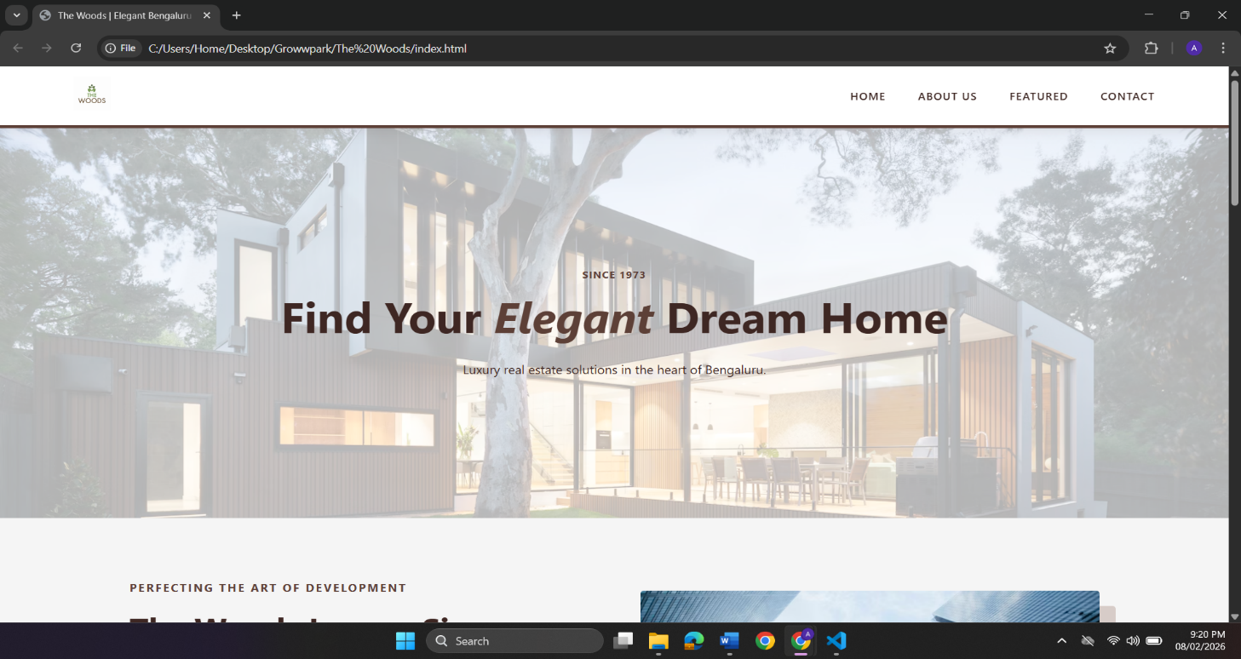

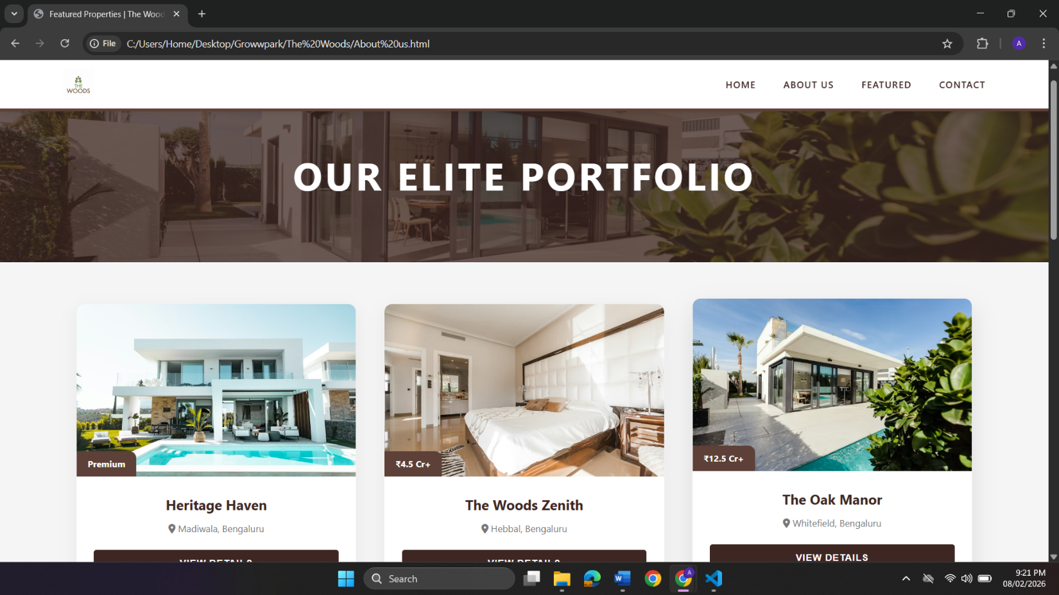
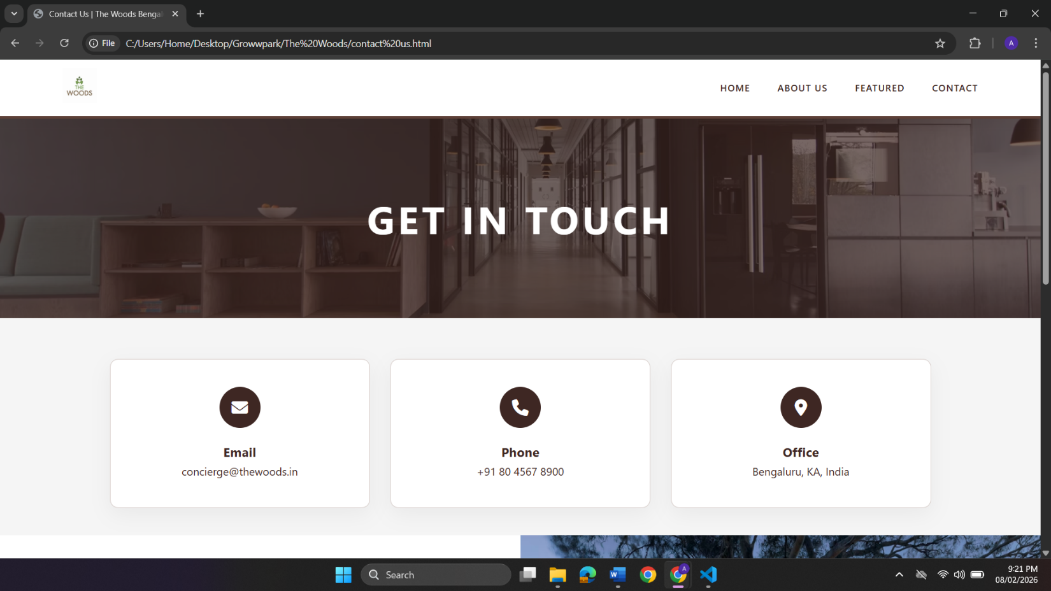
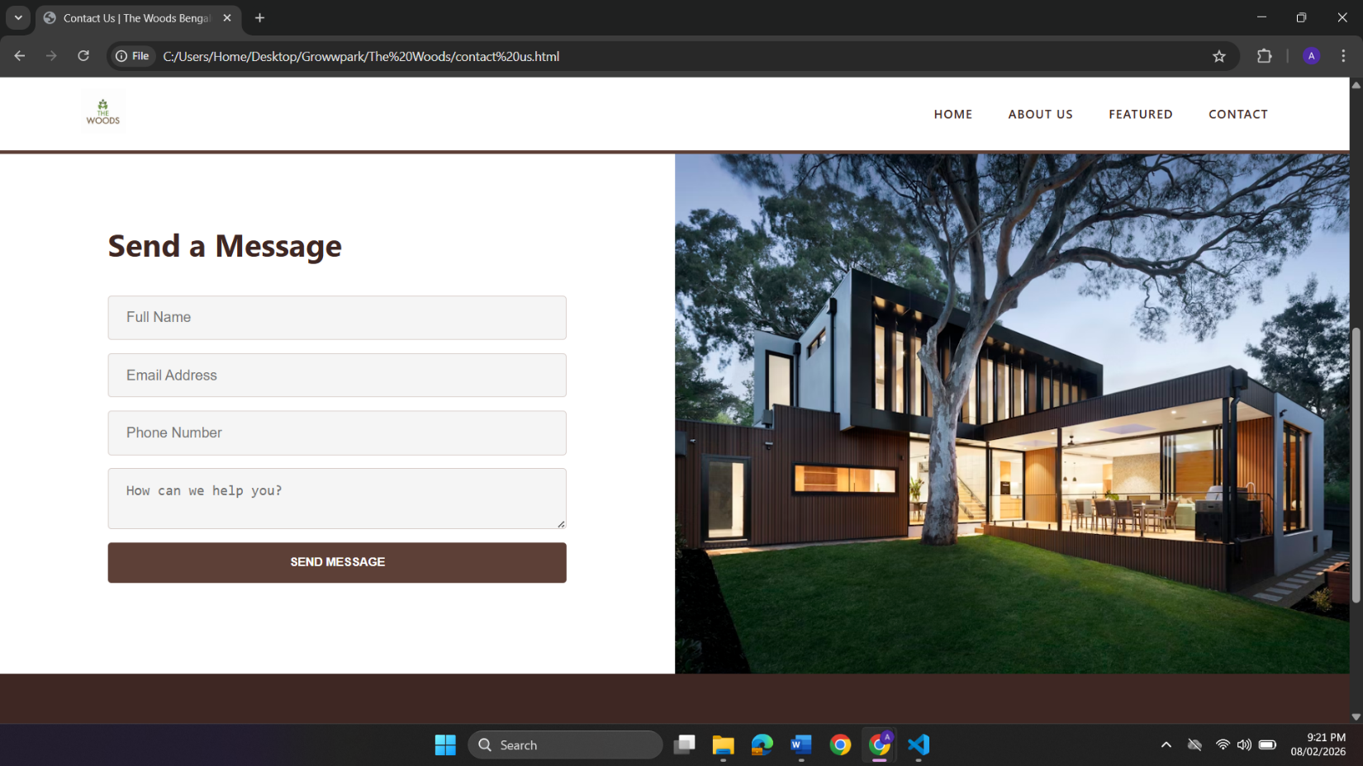

PROJECT ON E-COMMERCE WEBSITE DEVELOPMENT

- The project involved designing a responsive e-commerce website using HTML, CSS, and JavaScript to simulate an online shopping platform with a professional user interface.
- Key features such as product listings, featured products, new arrivals, promotional banners, and add-to-cart icons were implemented to enhance user engagement and usability.
- Responsive navigation and mobile-friendly design were achieved using JavaScript-based menu toggling, ensuring smooth accessibility across different devices.
- This project strengthened my front-end development skills, improved my understanding of website structure and user experience design, and provided practical exposure to real-world e-commerce website layouts.

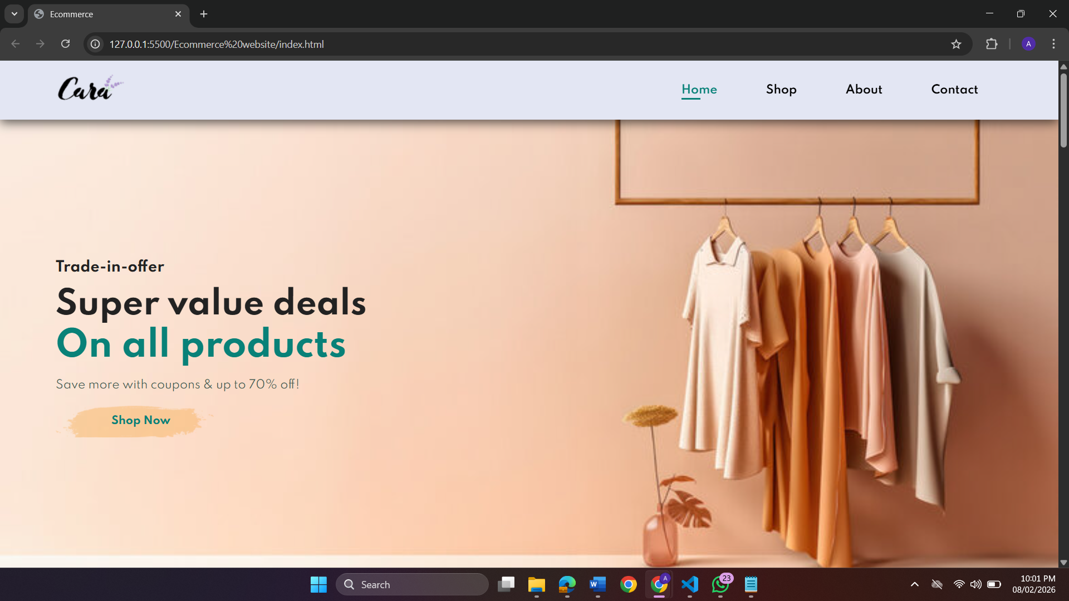
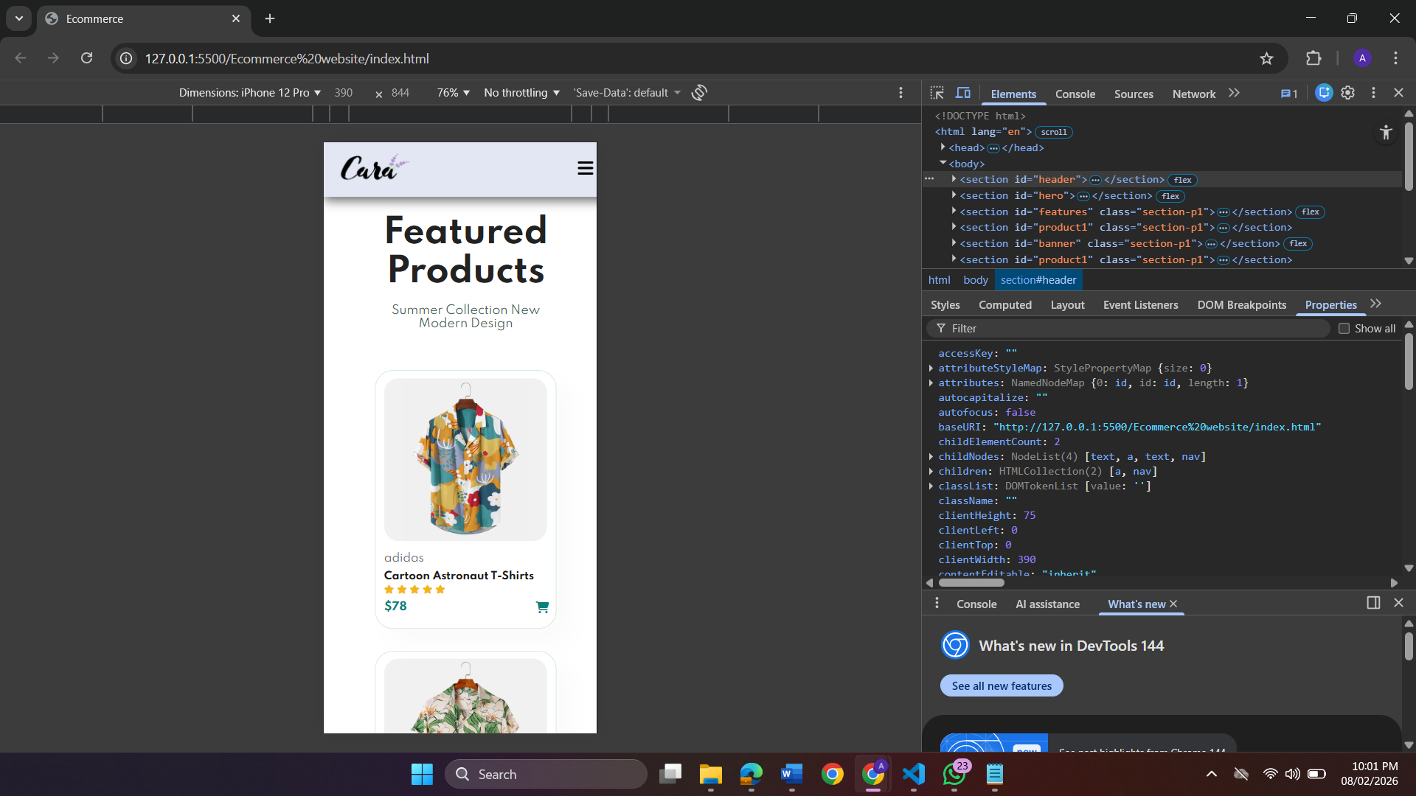
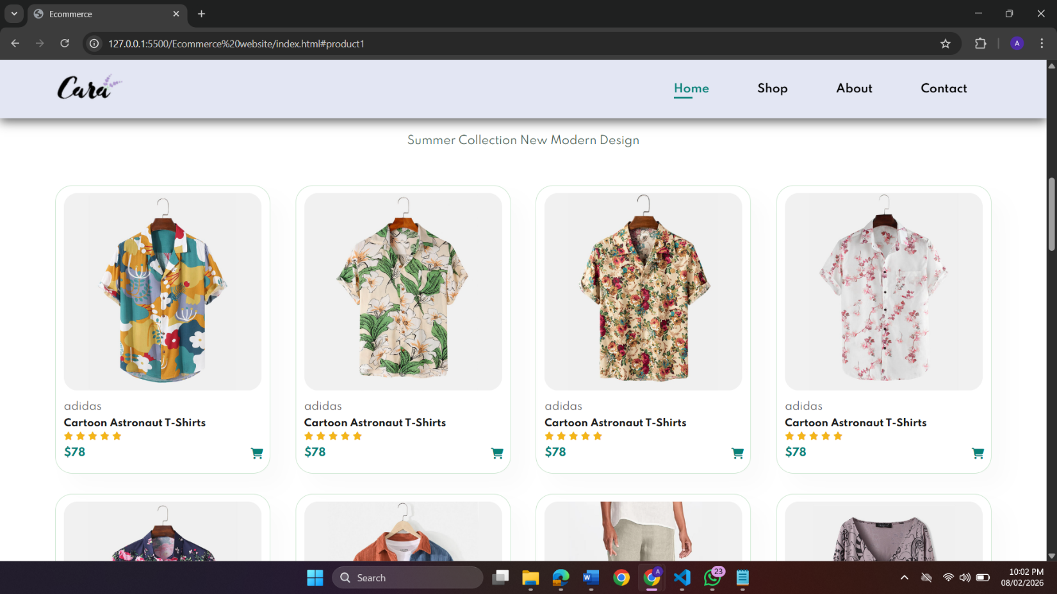
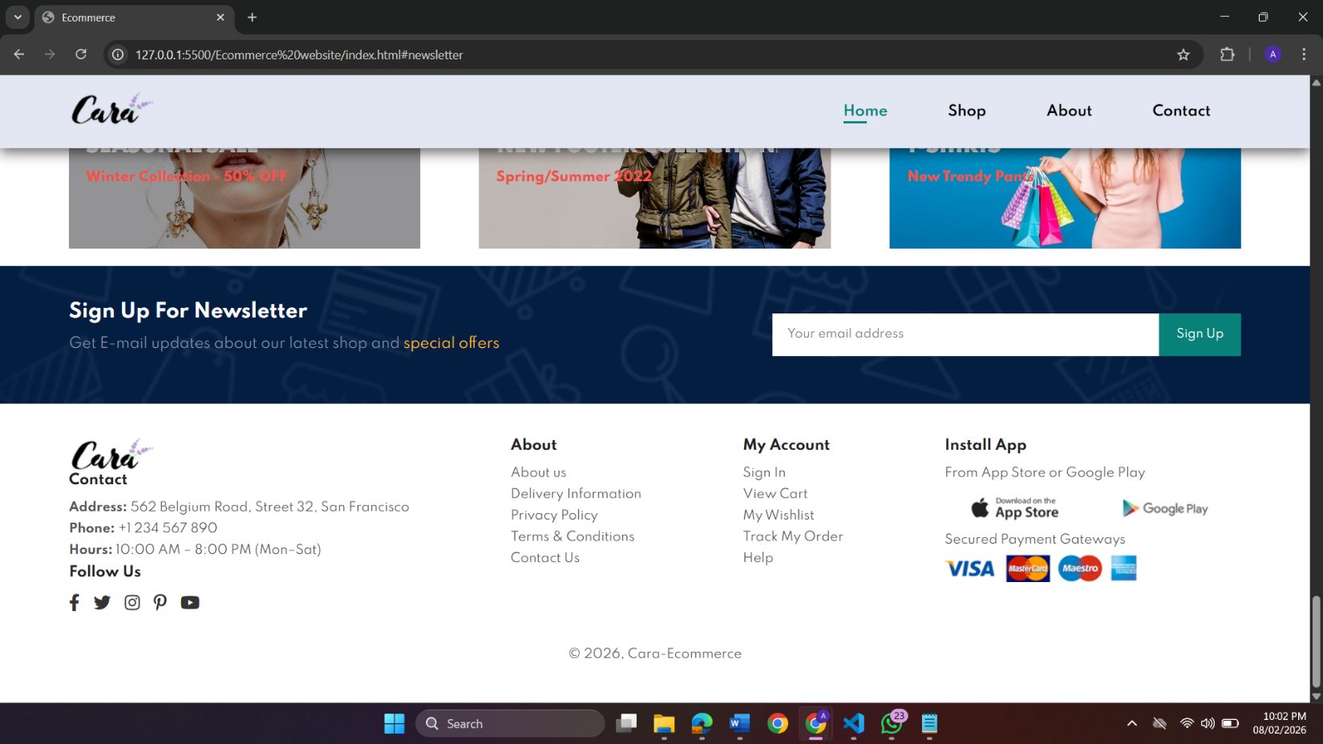

PROJECT ON COFFEE SHOP WEB DEVELOPMENT
- The project began with designing a modern and responsive coffee shop website to showcase products, brand identity, and customer engagement using HTML, CSS, and JavaScript.
- Key sections such as home, about, products, customer reviews, and contact were implemented to provide clear navigation and an informative user experience.
- Interactive features including a responsive navigation menu, search functionality, product cards, and add-to-cart buttons were added to enhance usability across desktop and mobile devices.
- This project helped me strengthen my front-end development skills, improve responsive design techniques, and gain practical experience in building real-world business websites.
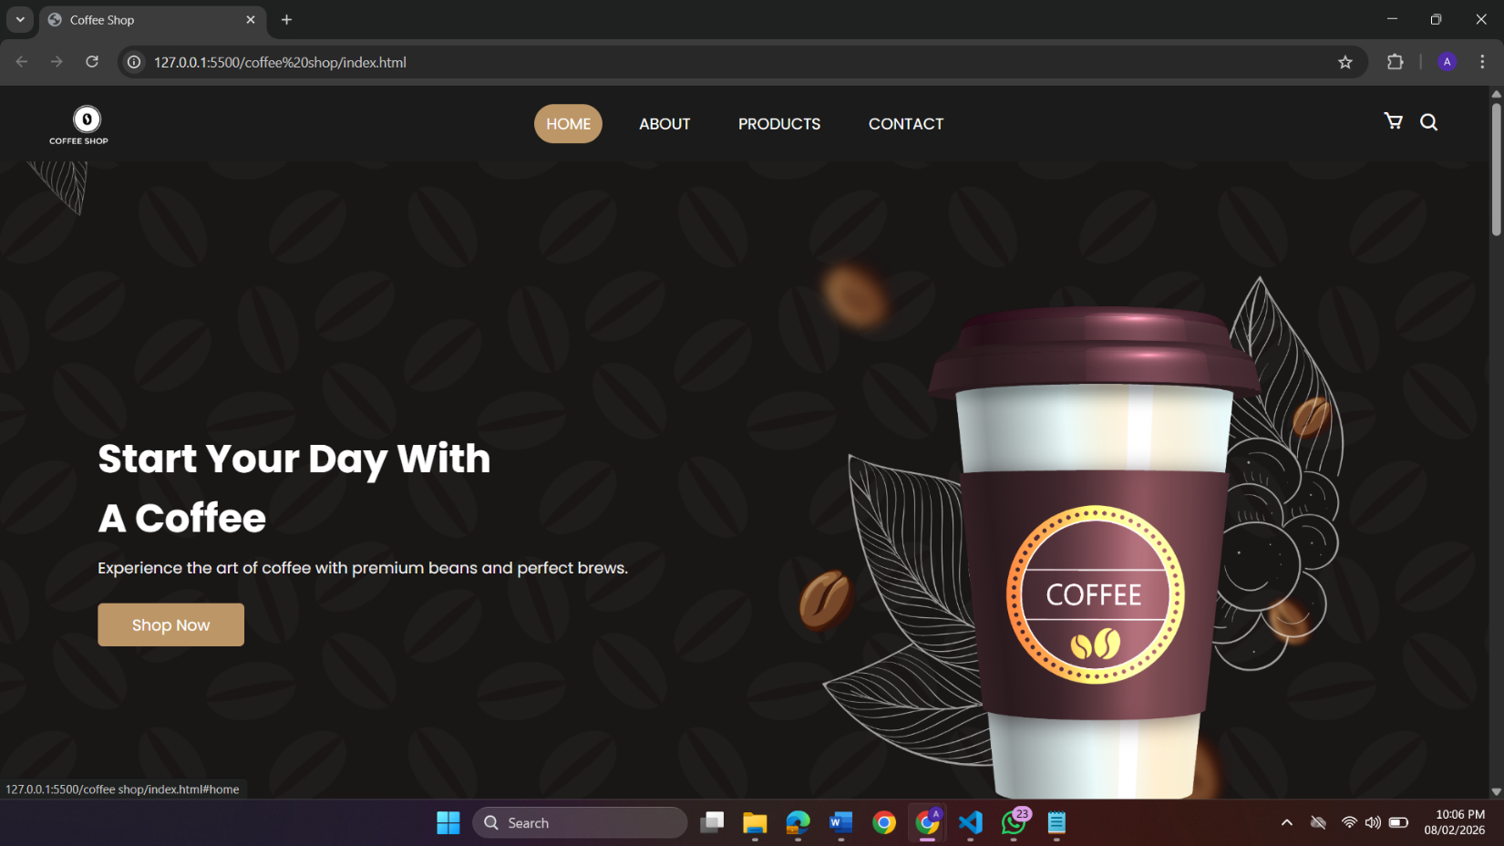+
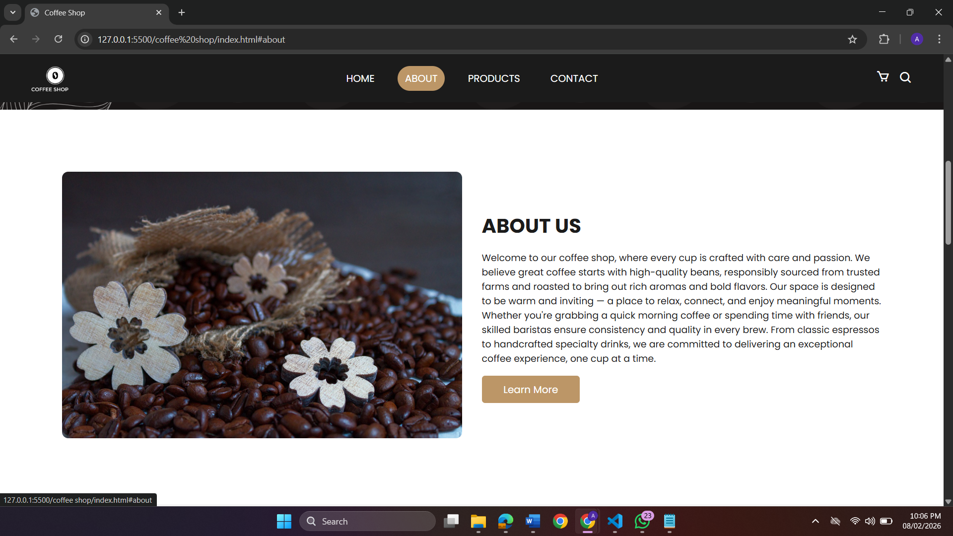
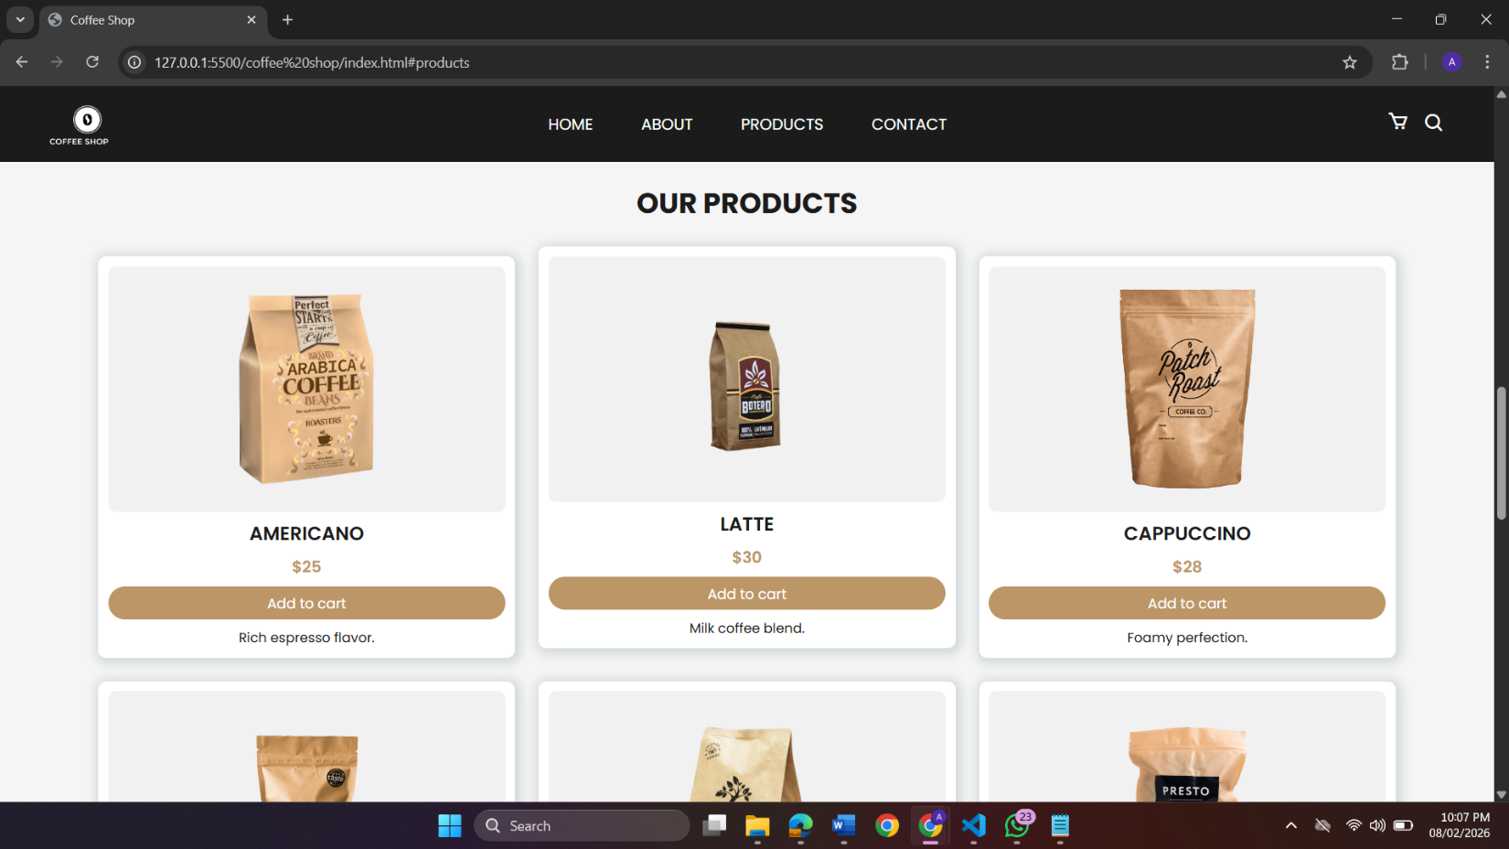
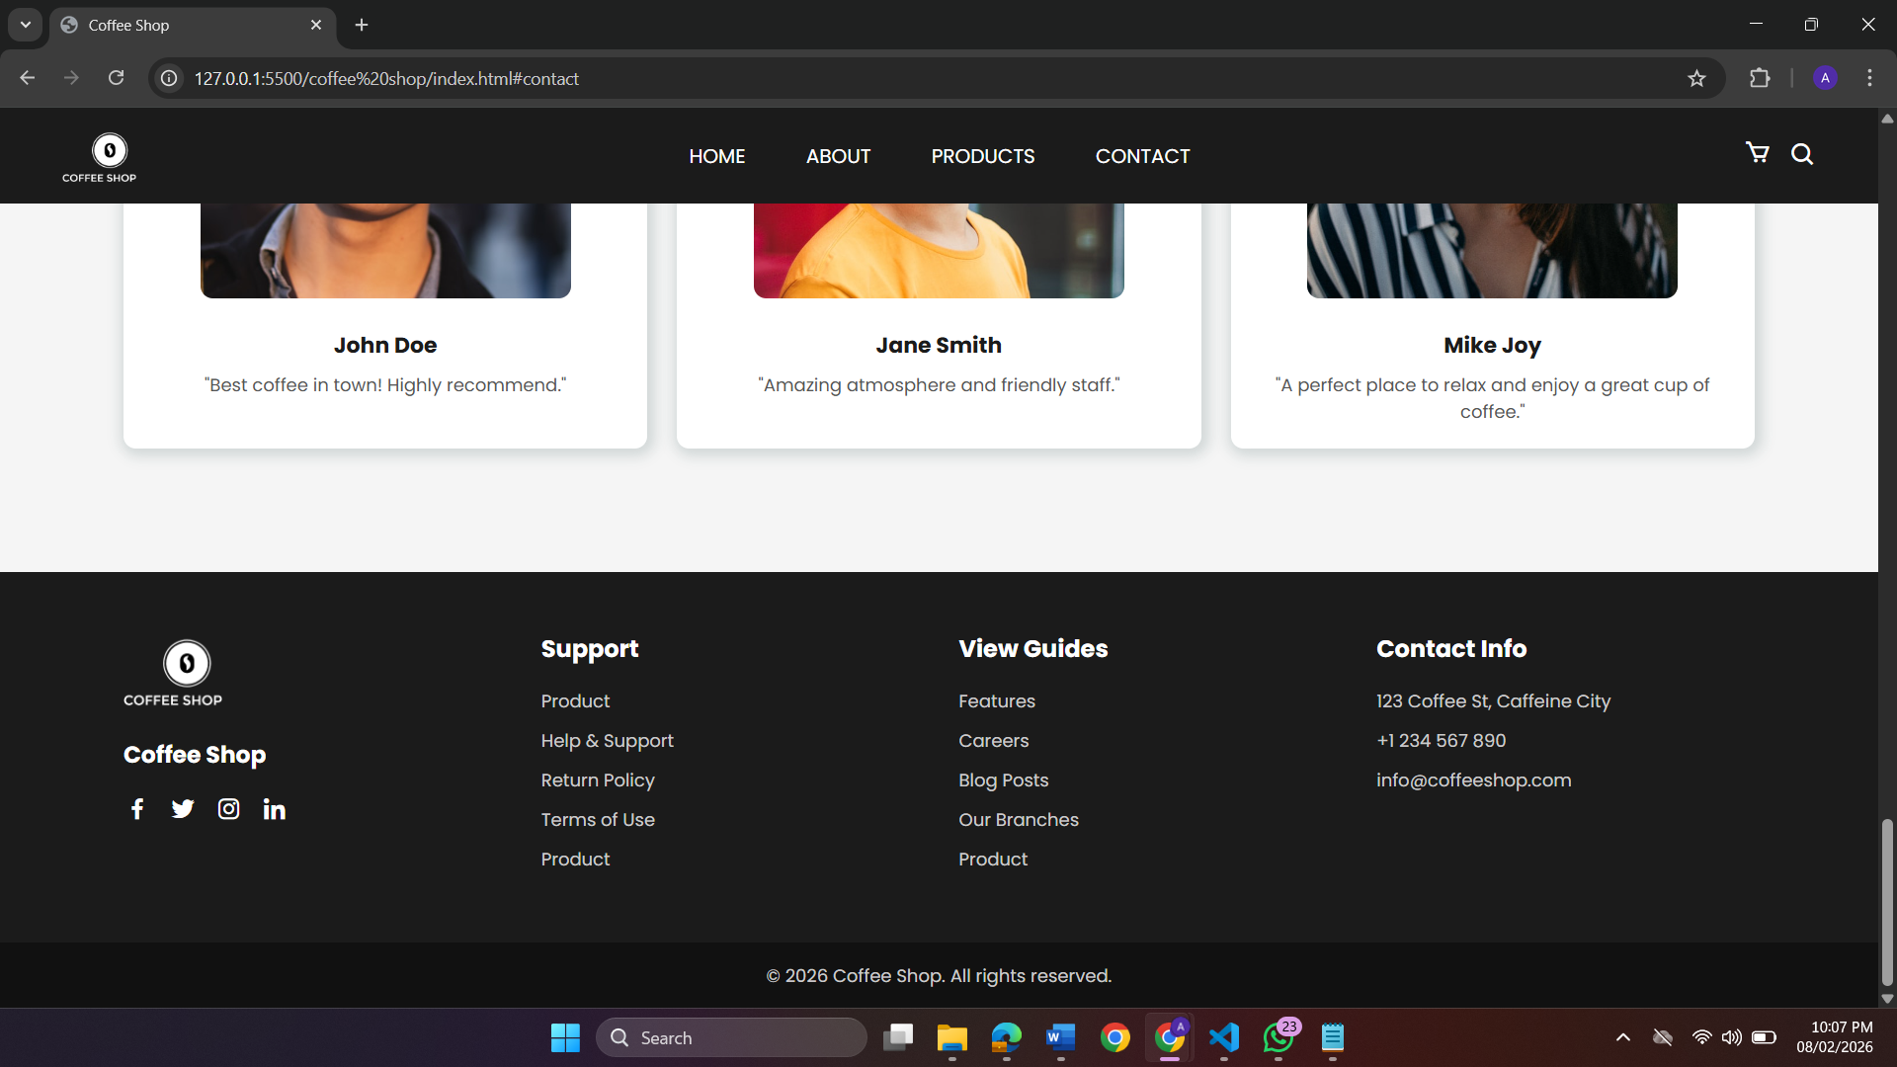

CHAPTER 5

Learning Outcomes

The internship at Growwpark Technologies Pvt. Ltd. provided me with a valuable opportunity to enhance my technical knowledge and develop professional skills related to frontend web development. This internship helped me gain practical exposure to real-time web development practices and understand how modern websites are designed, developed, and deployed.

Technical Skills

- Frontend Web Development
During the internship, I gained a strong understanding of HTML, CSS, and JavaScript, which enabled me to create well-structured, visually appealing, and interactive web pages. I learned how to design responsive layouts, apply proper styling techniques, and add dynamic behavior to websites, ensuring a better user experience across different devices.
- Website Deployment and Hosting
I acquired practical knowledge of website deployment and hosting using the Netlify platform. This included understanding the process of deploying static websites, managing build settings, and making web applications live and accessible to users. This experience gave me insight into how frontend projects move from development to production.
- Version Control and File Management
I gained basic exposure to version control concepts, understanding how project files are organized, updated, and managed efficiently. This helped me maintain clean project structures and track changes during development.

Soft Skills

1. Communication
I improved my verbal communication skills by actively participating in discussions with mentors and team members regarding assigned tasks and project progress. My written communication skills were enhanced through preparing documentation, maintaining task updates, and presenting completed work in a clear and structured manner.

2. Teamwork
The internship required close collaboration with team members while working on frontend development tasks. This experience helped me develop teamwork and coordination skills, including effective task sharing and cooperative problem-solving. I also learned the importance of accepting constructive feedback and implementing suggestions to improve the quality of my work.

3. Time Management
Working on multiple assignments helped me understand the importance of time management and prioritization. I learned to plan tasks efficiently, complete work within deadlines, and maintain consistency and productivity in a professional work environment.

Industry Knowledge

- I gained practical insights into how web development projects are conceptualized, planned, and executed within a professional work environment.
- I learned the importance of understanding client requirements and delivering high-quality outputs within stipulated timelines and deadlines.
- I became aware of emerging trends and best practices in the IT industry, including the use of automation to streamline routine and repetitive tasks.

Professional Development
- The internship helped me develop a professional work ethic, focusing on punctuality, accountability, and attention to detail.
- I learned to accept constructive criticism and apply feedback to improve my performance and deliverables.
- My problem-solving and critical-thinking abilities were significantly enhanced through real- world project challenges.

CHAPTER 6

Challenges Faced

During my internship, I encountered several challenges that tested my learning ability, problem-solving skills, and adaptability. Overcoming these challenges played a crucial role in my technical and professional growth. The major challenges faced and the solutions adopted are described below.

1.Understanding Frontend Technologies

Challenge:
At the beginning of the internship, gaining a clear understanding of how HTML, CSS, and JavaScript work together to build responsive and interactive web pages was challenging. Implementing layouts, styling elements properly, and adding interactivity required careful learning and practice.

Solution:
To overcome this, I regularly practiced writing code and experimented with different layouts and styles. I referred to online documentation and tutorials to strengthen my understanding of frontend concepts. Guidance from mentors also helped me correct mistakes and improve my coding approach.

2. Designing Responsive Web Pages

Challenge:
Creating web pages that functioned well across different screen sizes and devices was initially difficult, especially while managing layouts and alignment.

Solution:
I learned to use responsive design techniques such as flexible layouts and media queries. Continuous testing on different screen resolutions helped me improve the responsiveness and usability of the web pages.

3. Website Deployment and Hosting

Challenge:
Deploying websites and understanding the hosting process using Netlify was a new experience. Managing build settings and ensuring the website worked correctly after deployment was challenging at first.

Solution:
I followed step-by-step deployment procedures and practiced hosting multiple sample projects on Netlify. This helped me understand the deployment workflow and troubleshoot errors efficiently, gaining confidence in making websites live.

4. Time Management

Challenge:
Completing assigned tasks within given deadlines while learning new concepts simultaneously required effective time management.

Solution:
I organized my daily tasks, set clear priorities, and followed a structured work schedule. Breaking tasks into smaller steps helped me complete work efficiently without compromising quality

5. Communication and Coordination

Challenge:
Communicating task progress and clarifying doubts in a professional environment was initially challenging.

Solution:
I actively interacted with mentors, asked questions whenever needed, and shared regular updates on my work. This improved clarity, coordination, and overall productivity.

6. Adapting to a Professional Work Environment

Challenge:
Adjusting from an academic environment to a professional work culture required discipline, consistency, and adherence to standards.

Solution:
By following instructions carefully, maintaining punctuality, and accepting feedback positively, I gradually adapted to the professional workflow and expectations of the organization.

CHAPTER 7

Conclusion
My internship was an enriching and transformative experience that contributed significantly to my personal and professional development. Over the course of the internship, I gained hands-on experience in frontend web development, worked on practical web-based tasks, and learned how professional projects are executed in a real-world environment.
This internship provided me with the opportunity to enhance my technical skills in HTML, CSS, and JavaScript, along with gaining practical knowledge in website deployment and hosting using Netlify. In addition to technical expertise, I also developed essential soft skills such as communication, time management, teamwork, and adaptability, which are crucial for success in the IT industry. Overcoming various challenges helped me build confidence, improve problem-solving abilities, and understand the importance of delivering quality work within deadlines.
The experience offered valuable insights into the web development industry, including current practices and professional standards followed in IT organizations. It has reinforced my long-term career goal of becoming a proficient full-stack developer and motivated me to continue learning advanced backend technologies and modern frameworks to complement my frontend skills.

Impact on Career Goals

- This internship has strengthened my confidence in applying frontend development skills to real-world projects and has prepared me for future roles in web and software development.
- Exposure to professional workflows, task-based development, and deployment practices has provided a strong foundation for my long-term career growth in the IT field.

Recommendations for Future Interns

• Be proactive: Take initiative to learn new technologies and explore tools beyond assigned tasks.

• Manage your time effectively: Prioritize tasks, follow deadlines, and maintain consistency in work.

• Embrace challenges: View every difficulty as a learning opportunity and seek guidance when needed.

• Engage actively: Participate in discussions, ask questions, and make the most of mentorship and feedback.

In conclusion, this internship at Growwpark Technologies Pvt. Ltd. served as an important milestone in my career journey. It equipped me with practical technical knowledge, professional discipline, and a clear understanding of industry expectations. The experience has prepared me to face future professional challenges with confidence and has laid a strong foundation for my growth in the field of web development..

CHAPTER 8

References

The following resources and materials were referred to during the development of the GrowwPark project using HTML, CSS, and JavaScript, to support learning and project implementation:

1. Technical Documentation

• HTML5 Documentation (MDN Web Docs): Used for structuring web pages and organizing content effectively.
https://developer.mozilla.org/en-US/docs/Web/HTML

• CSS3 Documentation (MDN Web Docs): Referenced for styling, layout design, and responsiveness.
https://developer.mozilla.org/en-US/docs/Web/CSS

• JavaScript Documentation (MDN Web Docs): Used for implementing interactivity, form validation, and dynamic functionality.
https://developer.mozilla.org/en-US/docs/Web/JavaScript

2. Tools and Development Environment

• Visual Studio Code Documentation: Used as the primary code editor for developing and managing project files.
https://code.visualstudio.com/docs

• Google Chrome Developer Tools: Utilized for debugging, testing responsiveness, and performance analysis.

3. Project-Specific Learning Resources

• Online tutorials on responsive web design and frontend development concepts.
• Technical discussions and problem-solving references from Stack Overflow.

4. Design and UI References

• Web design inspirations for layout structuring and user interface improvements.
• Free UI resources and icon libraries used to enhance visual appearance.

